**Getting started with Galileo Gen 2**

### **Requirements**

* An Intel® Galileo Gen 2 Board
* One 7-15V DC power supply. It should have come with your board.
* One micro-USB cable
* USB Serial cable
* A Windows* computer

### **Setup** (If you have a micro-SD card in your board, remove it.)

1. Plug in the power supply to your board.  Always plug in the power supply before the USB cable.

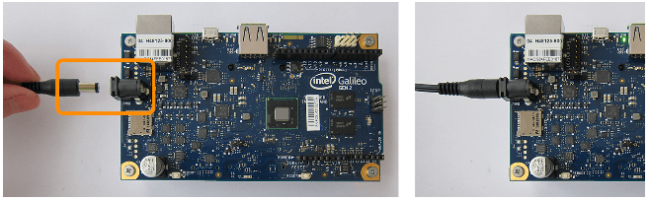

Wait for 2 LED’s to light up.

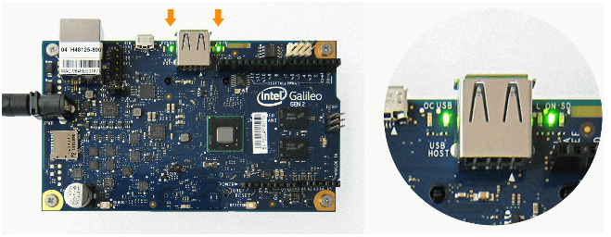

2. Plug in the micro-USB cable to your board's **USB client**port and the other end to your computer.

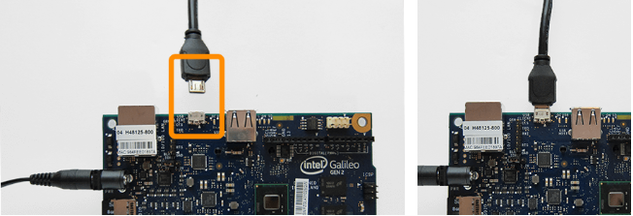

3. Plug in the 6 pin Serial to USB cable and the other end to your computer.

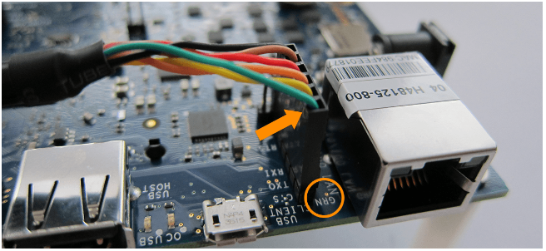

### **Install and Run Firmware Updater tool**

1. Download and unzip the Intel Galileo Firmware Updater, from the following link, for [Windows](https://downloadcenter.intel.com/downloads/eula/24748/Intel-Galileo-Firmware-and-Drivers-1-0-4?httpDown=http%3A%2F%2Fdownloadmirror.intel.com%2F24748%2Feng%2FIntelGalileoFirmwareUpdater-1.0.4-Windows.zip)

(https://downloadcenter.intel.com/downloads/eula/24748/Intel-Galileo-Firmware-and-Drivers-1-0-4?httpDown=http%3A%2F%2Fdownloadmirror.intel.com%2F24748%2Feng%2FIntelGalileoFirmwareUpdater-1.0.4-Windows.zip)

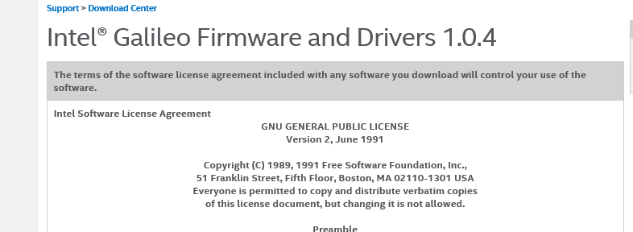

Scroll to bottom of page in figure above and click **“I accept the terms in the license agreement”**

2. If asked do you want to Open or Save (see figure below), select Open, alternatively it may open automatically.



3. From unzip package, use 1-click Unzip or Unzip button to Unzip to my PC or cloud. Make a note of where you unzip the Driver to as it will be needed in the next step.

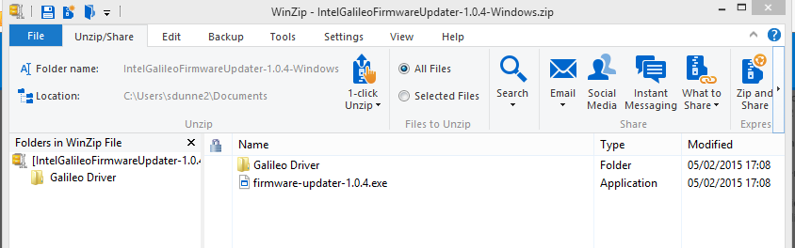

4. Install the driver by following these steps.

a. Open the **Device Manager**. (From the Start menu, open up the **Control Panel** and then Device Manager.

b. Under “Other Devices” see figure below you should see an open port named **Gadget Serial V2.4** (if the board contains an old release like v0.7.5) or simply **Galileo** on newer releases.

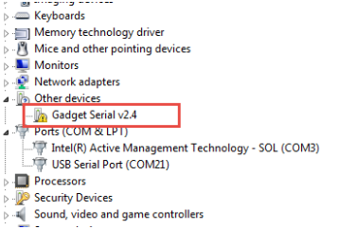

c. Right-click on the Gadget Serial V2.4 or Galileo port and choose the **Update Driver Software** option.

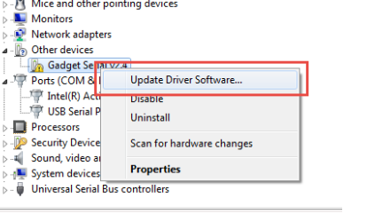

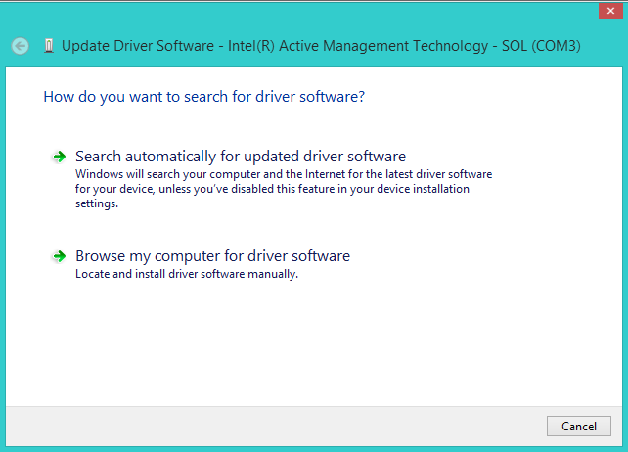

d. Select **Browse my computer for driver software**, as in figure above.

e. Navigate to the location of the **Intel Galileo Firmware Updater** folder**.**

f. Once the driver is successfully installed, the Device Manager will show confirmation screen as in below.

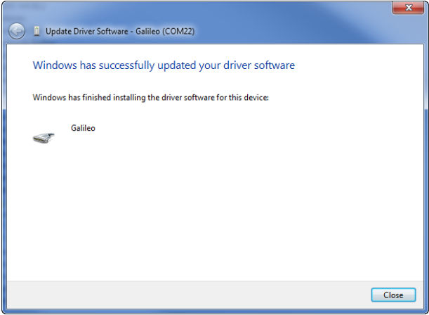

g. And a Galileo (COMx) device under Ports (COM & LPT), as shown in the figure below. Make a note of this COM port for later use.

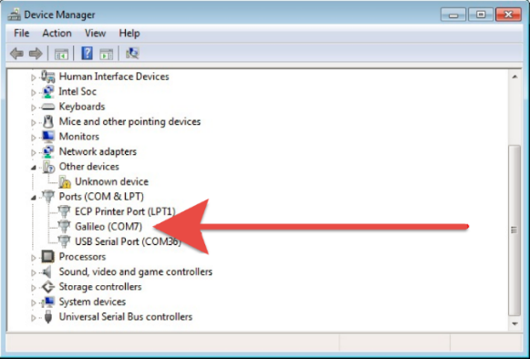

5. If you have Galileo firmware already installed, then the Galileo Firmware updater opens. Inside the Intel Galileo Firmware Updater, select the port of your board. For Windows it will be the COM port as found above. When you see the device add in, you can then use the Firmware updater to connect to that port.

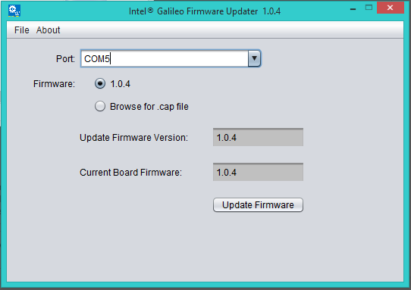

6. Select **Update Firmware**. Then it will ask you to confirm that you have your power supply connected. Once started, the update process will take approximately 5 minutes.

Click Install FTDI Driver

1. Download the FTDI driver for Windows (Source: <http://www.ftdichip.com/Drivers/D2XX.htm>)

2. Click on [setup executable](http://www.ftdichip.com/Drivers/CDM/CDM%20v2.12.00%20WHQL%20Certified.exe) as per following image.

3**. Save as**, as opposed to run, at a known location.

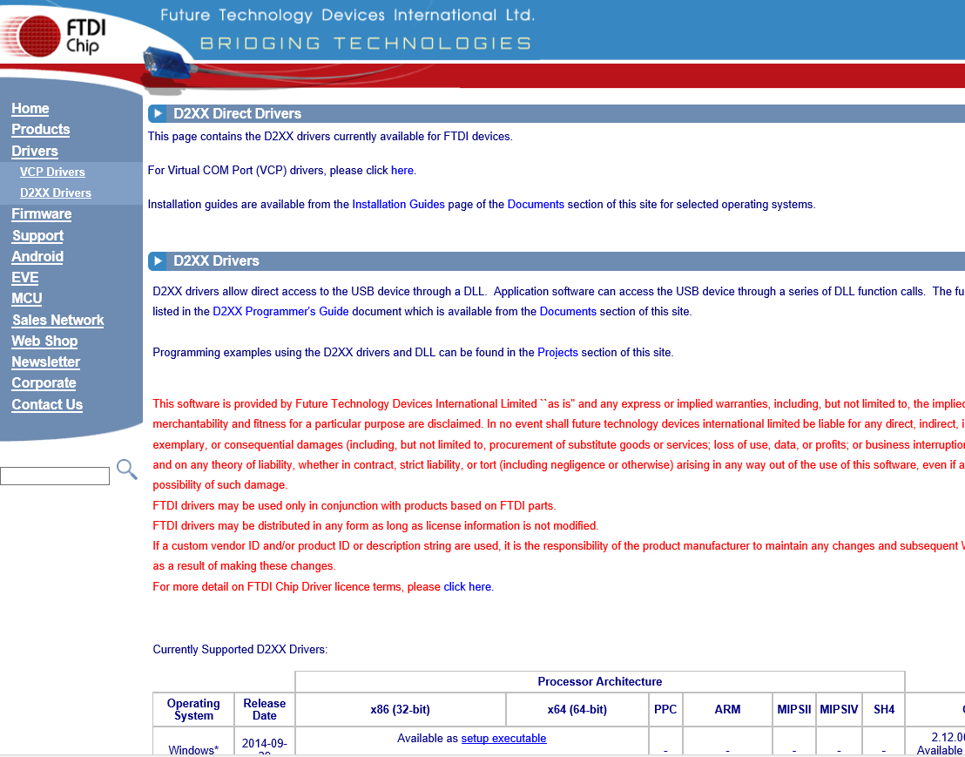

4. Right-click the .exe file you downloaded, which should be called “CDM…” and select Run as Administrator:

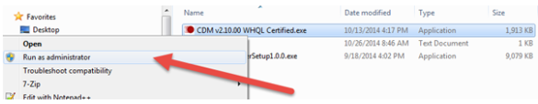

1. Click Extract.

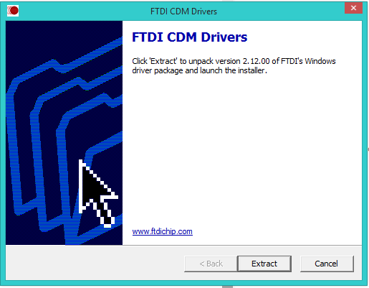L

1. Click Next.

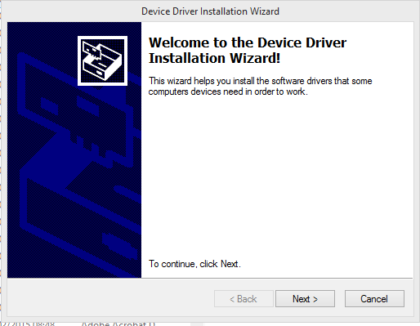

1. Click “I accept this agreement”, Click Next.
2. Click Finish
3. You should see a new USB Serial Port entry in the “Ports (COM & LPT)” section of the Device Manager.

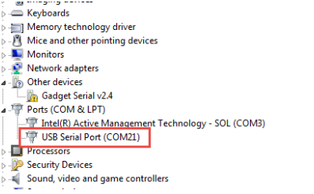

5. **Install USB Driver**, Arduino IDE.

a. If you haven't already, install 7zip, a free archive utility that can be downloaded at: [www.7zip.org](http://www.7zip.org/). See figure below, download non Beta version and appropriate version for your PC.

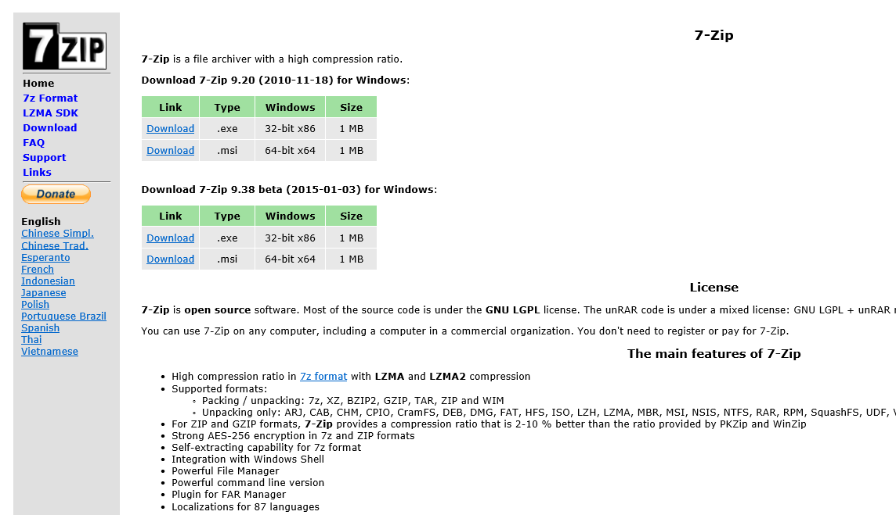

Select Run, and accept prompts, following instructions.

b. Go to [Download](http://www.intel.com/support/galileo/sb/CS-035101.htm) site. <http://www.intel.com/support/galileo/sb/CS-035101.htm> . Select the Arduino Windows link below to begin install. When asked to “Open” or “Save as”, select “Save as” and save in a known loaction.

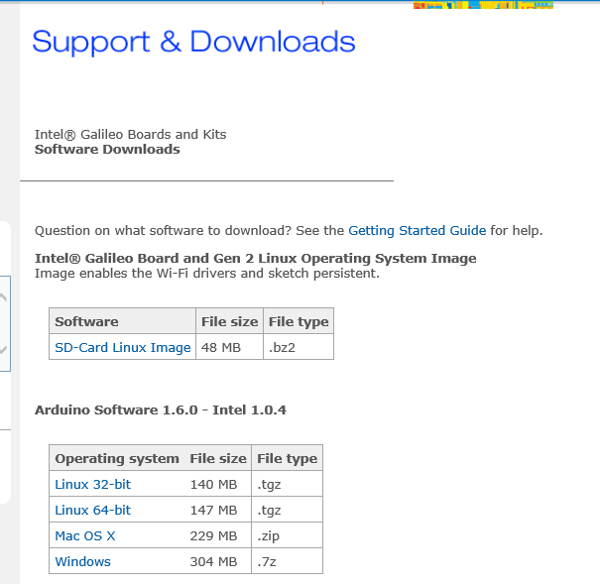

c. Navigate to the folder where you downloaded the Arduino IDE .zip file.

d. Right-click on the .zip file, point to **7-zip**, and select **Extract here-…"**. As per below figure

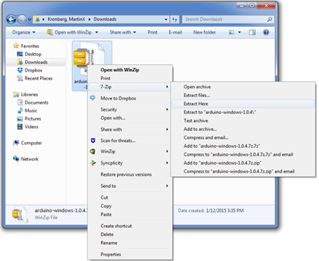

b. Unzip the file to the top directory of your computer (C:/) as shown in Figure 3. You can rename the folder to something descriptive; however, make sure there are no spaces in it.

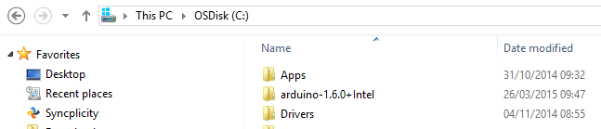

c. Open Arduino.exe, by double-clicking. Note: if you get a message asking if you want to visit the Arduino download page to update, select ***"No"***

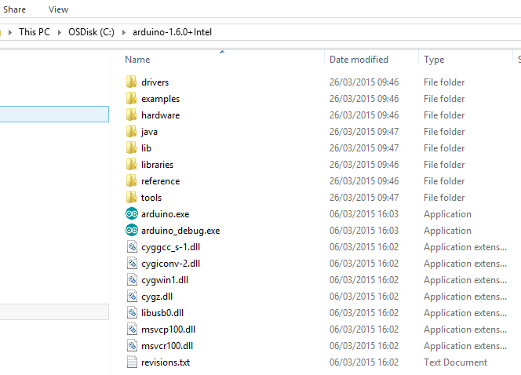

d. Using Arduino IDE, go to the Tools pull-down menu at the top, select Board, and make sure “Intel Galileo” or "Intel Galileo Gen2" is selected, depending on which board you are using, as shown in following image.

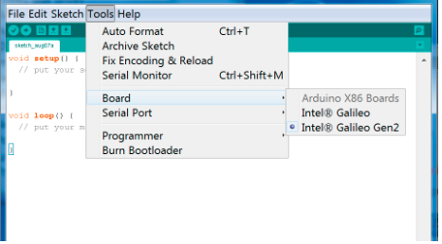

e. Now, go to Tools -> Serial Port in the menu. Select the serial port that looks like this: COMx, where “x” is the number you found above. (COM22 in this example for Galileo)

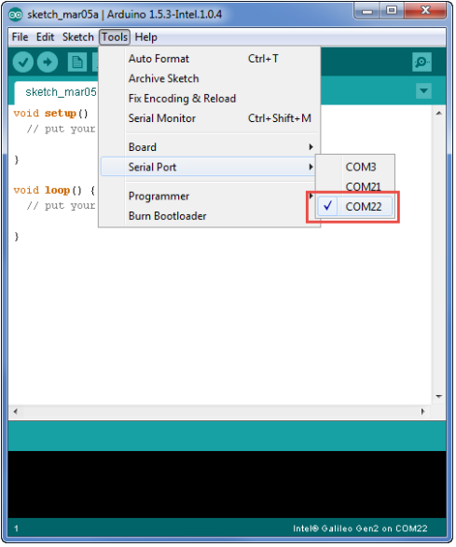

## 6. Open the blink example LED Arduino IDE

## This guide will teach you how to run a sample sketch on your Intel® IoT board using the Arduino IDE.

## a . Double-click on arduino.exe in the folder you extracted it.

## 

## b. Open the LED blink example sketch: File > Examples > 1.Basics > Blink. You should see a window like in below.

## 

c. Open the LED blink example sketch: **File > Examples > 1.Basics > Blink**. Click on the upload button.

## 

d. You should see a "Done Uploading" and a "Transfer complete" when it has uploaded.

## 

## 

e. You should see the highlighted LED blinking if successful.

## Install PuTTY

1. Check for a **"USB Serial Port"**(not "Intel Edison Virtual Com Port") in the Device Manager.

[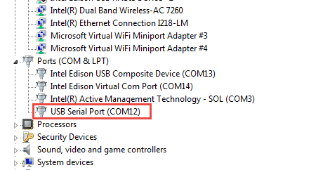](https://software.intel.com/sites/default/files/managed/b3/0c/Edison_Windows_usbserialport_cropped_3-4-15_0.png)

1. Download the PuTTY terminal emulator: [http://the.earth.li/~sgtatham/putty/latest/x86/putty.exe.](http://the.earth.li/~sgtatham/putty/latest/x86/putty.exe)
2. Double-click the putty.exe file you downloaded to run it. Save this in a known location for future use.
3. Configure the PuTTY menu as follows, like in next diagram
   1. Select **Serial** under Connection type.
   2. Enter your **COM#** (the number you found above)
   3. Enter **115200** for the Speed

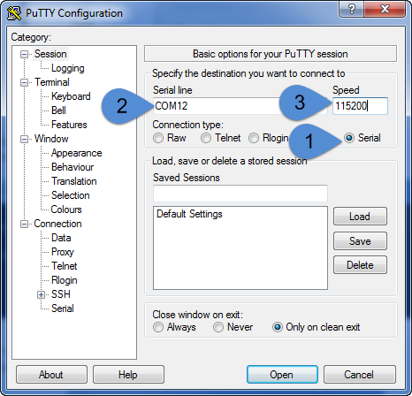

When you see a blank screen, press the Enter key twice, you should see a login screen like below  
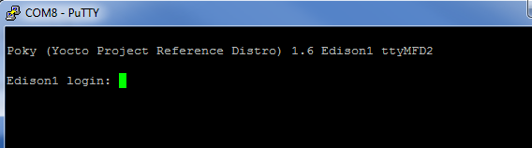

**8. Get your board online.**

Components

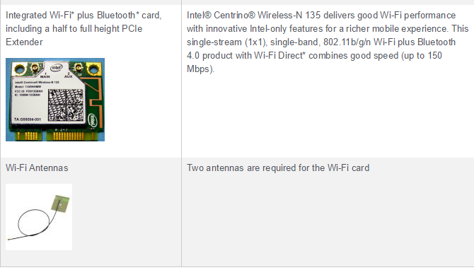

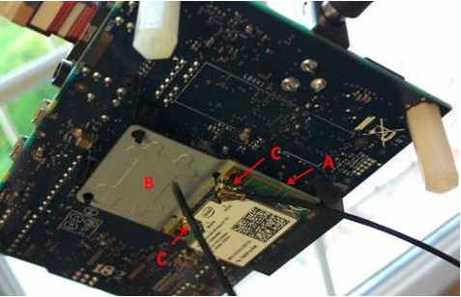

**Installing**

Installing the Integrated Wi-Fi plus Bluetooth card Wireless Module

To install the Intel Centrino Wireless-N 135 adapter (A), screw the extender (B) to the card and snap them into place on the board (see picture). Then Insert the antennas into the two jacks (C) on both sides of the adapter.

If you want to install a different half-size adapter, you'll have to use a half to full-size extender (B) in order to properly mount it.

**Connecting to a Wi-Fi Network**

Ensure system is powered down, insert SD card with image installed and boot up.

Once connected via serial, hit Return twice Get to Galileo root.

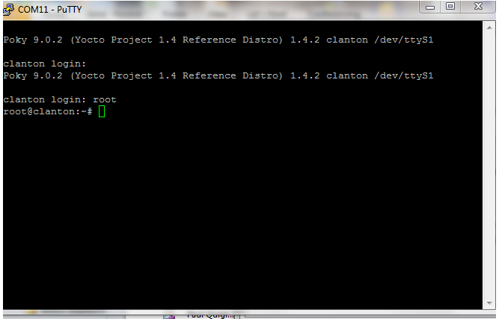

Enable WiFi with following command

* ifup wlan0

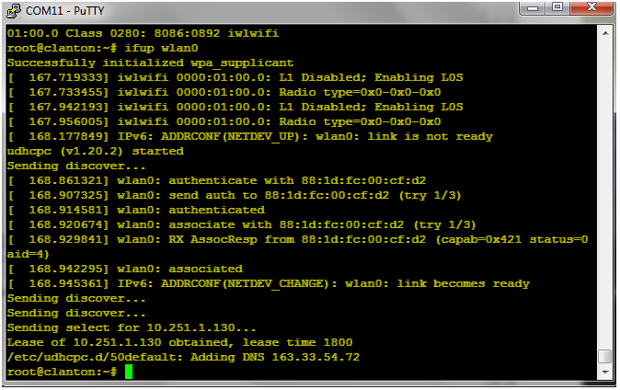

Revert to Arduino IDE

Load – File -> Examples ->Wifi -> Scan Networks